Hands-On Lab
Lab Manual
Develop a simple servlet application

Contents
Develop a simple servlet application i
Lab: A simple servlet application tutorial 3
Lab Objectives 3
Exercise 1 – Create web application 3
1. Create a Dynamic Web Application 3
2. Modify context path into the lowercase 4
3. Configure the resource to support Unicode 5
Exercise 2 - Writing Login servlet 6
1. Create a new servlet by press Ctrl + N 6
2. Input information for servlet 7
3. Write code for LoginServlet 9
4. Overview the method doGet 10
5. Create the index page “index.jsp” 11
6. Create the login page “login.jsp” 11
7. Run the web application 12
Exercise 3 – Create Login form and upgrade the LoginServlet 13

Lab: A simple servlet application tutorial
Estimated time to complete this lab: 45 minutes

Lab Objectives
The objective of this lab is to introduce you how to create a simple servlet with eclipse.
- Create a dynamic web project in clipse.
- Write a jsp home page to forward to servlet
- Write a servlet
- Running the application with Tomcat.

Prerequisite:
- Finished labs: Install JDK and Tomcat, Configure Eclipse.

Exercise 1 – Create web application
  - Create a Dynamic Web Application
Going to menu File > New > Dynamic Web Project. Input the Project name “BodyCheck” (without double quotes).
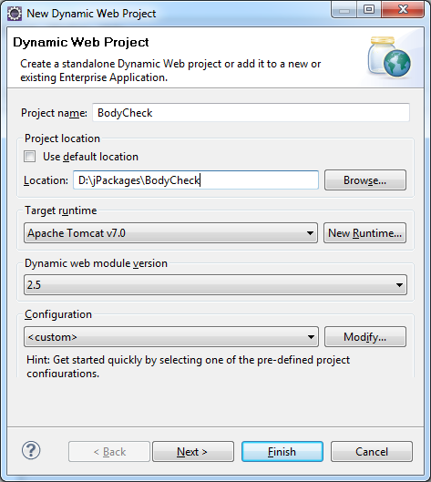
Select Target runtime is “Apache Tomcat v7.0”; Dynamic web module version is “2.5”.
Click on Next twice.
  - Modify context path into the lowercase

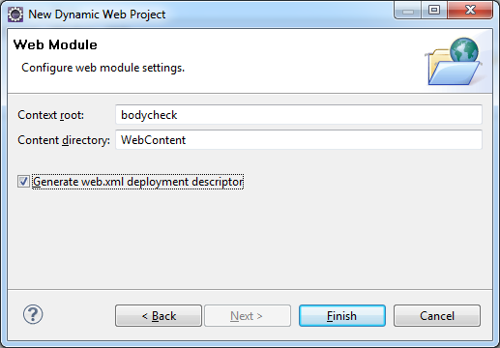
Click on Finish button. The structure of the project is:

The content of web application deployment are generate as below:
<?xml version="1.0" encoding="UTF-8"?>
<web-app xmlns:xsi="http://www.w3.org/2001/XMLSchema-instance" xmlns="http://java.sun.com/xml/ns/javaee" xmlns:web="http://java.sun.com/xml/ns/javaee/web-app_2_5.xsd" xsi:schemaLocation="http://java.sun.com/xml/ns/javaee http://java.sun.com/xml/ns/javaee/web-app_2_5.xsd" id="WebApp_ID" version="2.5">
<display-name>BodyCheck</display-name>
<welcome-file-list>
<welcome-file>index.html</welcome-file>
<welcome-file>index.htm</welcome-file>
<welcome-file>index.jsp</welcome-file>
<welcome-file>default.html</welcome-file>
<welcome-file>default.htm</welcome-file>
<welcome-file>default.jsp</welcome-file>
</welcome-file-list>
</web-app>
Remove all tag “welcome-file” exception tag “<welcome-file>index.jsp</welcome-file>”.
It means the default home page is index.jsp
  - Configure the resource to support Unicode
 In case you use the Open-Ones Group's eclipse, skip this step.
Right-click on the project, select Properties. The properties dialog is displayed as below

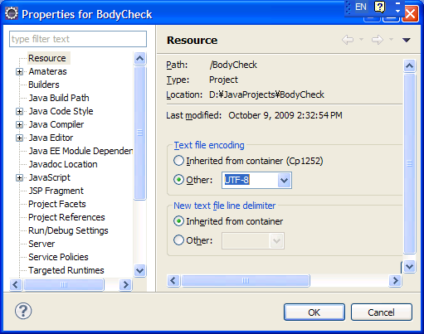
Select node “Resource”, choose value of “Text file encoding” is UTF-8.
Check the default JSP encoding in eclipse by going to Window > Preferences. Expand node Web > JSP Files. Select encoding for JSP file is “ISO 10646/Unicode(UTF-8).
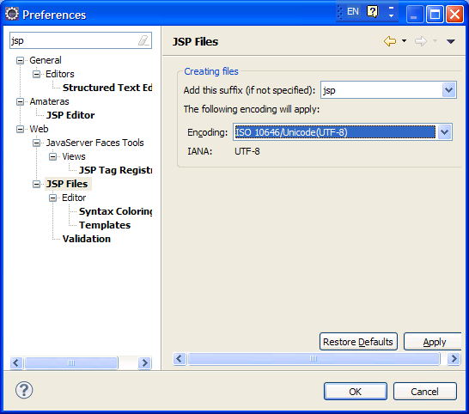

Exercise 2 - Writing Login servlet
  - Create a new servlet by press Ctrl + N
Select note “Web > Servlet”. Then click on Next button
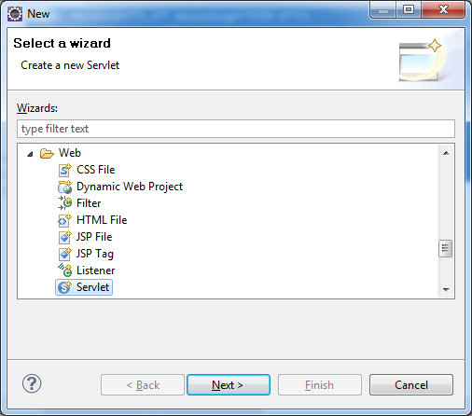
  - Input information for servlet
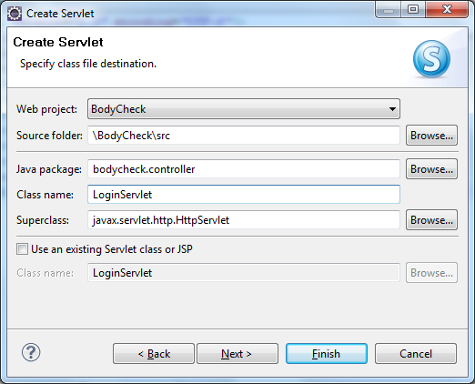
Click on Next button twice. Select below optional to generate source codes.
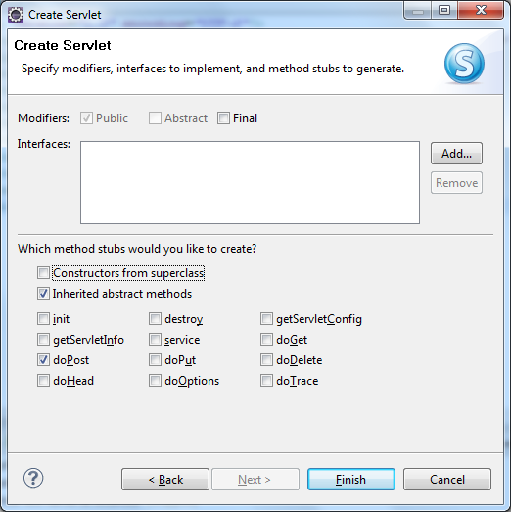
Click on Finish button.
Two files are generated/updates.
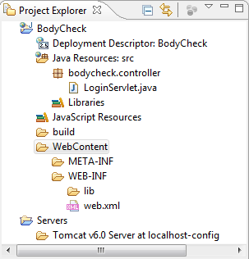
- File web application deployment web.xml is updated
<?xml version="1.0" encoding="UTF-8"?>
<web-app xmlns:xsi="http://www.w3.org/2001/XMLSchema-instance" xmlns="http://java.sun.com/xml/ns/javaee" xmlns:web="http://java.sun.com/xml/ns/javaee/web-app_2_5.xsd" xsi:schemaLocation="http://java.sun.com/xml/ns/javaee http://java.sun.com/xml/ns/javaee/web-app_2_5.xsd" id="WebApp_ID" version="2.5">
<display-name>BodyCheck</display-name>
<welcome-file-list>
<welcome-file>default.jsp</welcome-file>
</welcome-file-list>
<servlet>
<description></description>
<display-name>LoginServlet</display-name>
<servlet-name>LoginServlet</servlet-name>
<servlet-class>bodycheck.controller.LoginServlet</servlet-class>
</servlet>
<servlet-mapping>
<servlet-name>LoginServlet</servlet-name>
<url-pattern>/LoginServlet</url-pattern>
</servlet-mapping>
</web-app>

- File LoginServlet.java is generated:
package bodycheck.controller;

import java.io.IOException;
import javax.servlet.ServletException;
import javax.servlet.http.HttpServlet;
import javax.servlet.http.HttpServletRequest;
import javax.servlet.http.HttpServletResponse;

/**
* Servlet implementation class LoginServlet
*/
public class LoginServlet extends HttpServlet {
private static final long serialVersionUID = 1L;

/**
* @see HttpServlet#doPost(HttpServletRequest request, HttpServletResponse response)
*/
protected void doPost(HttpServletRequest request, HttpServletResponse response)
throws ServletException, IOException {
// TODO Auto-generated method stub
}

}
  - Write code for LoginServlet
Write code for method doPost(request, response):
Logger.getLogger("LoginServlet").info("doPost.START");

Date currentDate = new Date();
SimpleDateFormat sdf = new SimpleDateFormat("EEEEE");
String today = sdf.format(currentDate);
request.getSession().setAttribute("TODAY", today);
request.getRequestDispatcher("login.jsp").forward(request, response);

Logger.getLogger("LoginServlet").info("doPost.START");
  - Overview the method doGet
Right-click on the space of source code LoginServlet, select Source > Override/Implement Methods…
Or using Alt+Shift+N
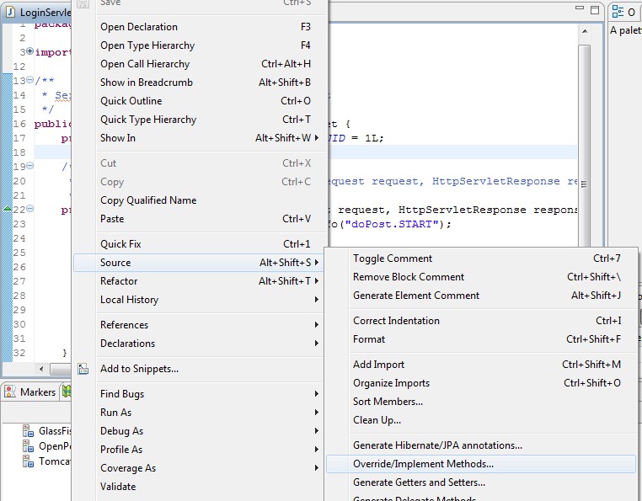
Right-click on the space of source code
Select the method will be overrided or implemented
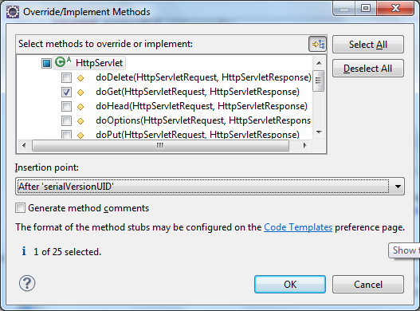
Then click OK button
Method doGet is generated into the LoginServlet.java. Now, add a statement to call the method doPost as below:
protected void doGet(HttpServletRequest req, HttpServletResponse resp) throws ServletException, IOException {
doPost(req, resp);
}

  - Create the index page “index.jsp”
Press Ctrl + N, Select node Web > JSP. Then click on Next button.
Select “parent folder” is “BodyCheck > WebContent”.
Input File name is “index” (all characters are in lowercase).
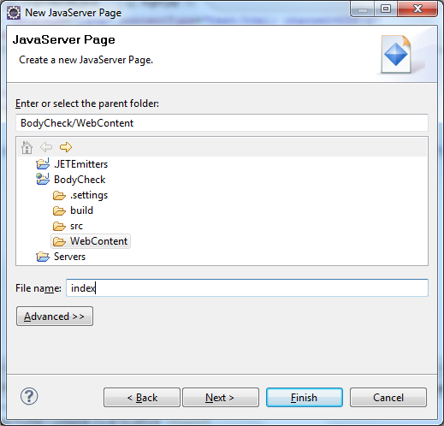
Then click on Next and Finish button.
The index.jsp file is generated. You add statement
<jsp:forward page="LoginServlet"></jsp:forward>
into the body tag. The final code of index.jsp is as below:
<%@ page language="java" contentType="text/html; charset=UTF-8"
pageEncoding="UTF-8"%>
<!DOCTYPE html PUBLIC "-//W3C//DTD HTML 4.01 Transitional//EN" "http://www.w3.org/TR/html4/loose.dtd">
<html>
<head>
<meta http-equiv="Content-Type" content="text/html; charset=UTF-8">
<title>Insert title here</title>
</head>
<body>
<jsp:forward page="LoginServlet"></jsp:forward>
</body>
</html>

  - Create the login page “login.jsp”
Press Ctrl + N, Select node Web > JSP. Then click on Next button.
Select “parent folder” is “BodyCheck > WebContent”.
Input File name is “login”. Then click on Finish button.
After the login.jsp is generated. Add below code for the body tag:
This is the login page. Current time is <%= session.getAttribute("TODAY") %>
The final login.jsp is:
<%@ page language="java" contentType="text/html; charset=UTF-8"
pageEncoding="UTF-8"%>
<!DOCTYPE html PUBLIC "-//W3C//DTD HTML 4.01 Transitional//EN" "http://www.w3.org/TR/html4/loose.dtd">
<html>
<head>
<meta http-equiv="Content-Type" content="text/html; charset=UTF-8">
<title>Login screen</title>
</head>
<body>
This is the login page. Current time is <%= session.getAttribute("TODAY") %>
</body>
</html>
Save all files.
  - Run the web application
Right-click on the project, choose Run As > Run on Server (or using hot key Alt-Shift-X. Next press R).
Then select the server to run the project. Finally, click on Finish button.
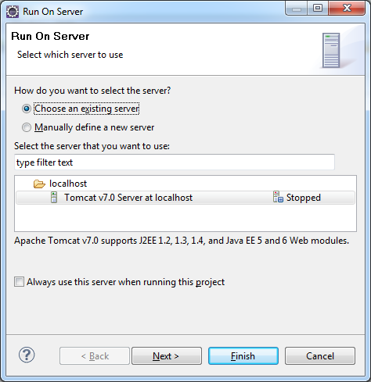
The configured default browser is displayed as below:
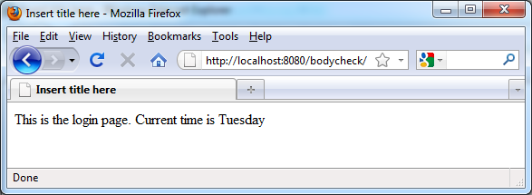

Now, you have created and run the simple web application with Servlet successfully. Congratulation!

Exercise 3 – Create Login form and upgrade the LoginServlet
Create the login form in login.jsp. The form contains 2 inputs “Email” and “Password” and a submit button. Click on submit button the LoginServlet is invoked to process Authentication in server side.

Please try it your-self!

